About Konark
Konark is a town situated in the Puri district in the state of Odisha, India. It is the site of the 7th century Sun Temple, also known as the Black Pagoda, built in black granite during the reign of Narasimhadeva-I. The temple is a world heritage site.
Konark is also home to an annual dance festival called Konark Dance Festival, devoted to classical Indian dance forms. Every year Konark Festival and International Sand Art Festival at Chandrabhaga beach of Konark have been organizing to attract world over artisans and tourists.
Top Attractions in Konark
Sun Temple
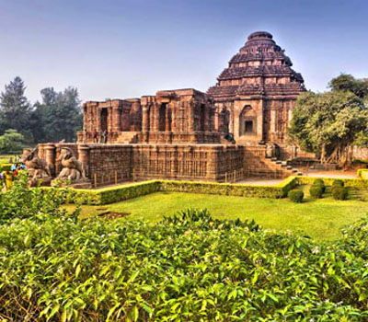
A UNESCO World Heritage Site, Konark Sun temple is a striking model of ancient Kalinga artistry and fluidity of ideas. Dedicated to the Sun god, Surya, the first rays of the sun fall on the entrance of the temple. Much of the temple has fallen into rack and ruin but what remains still holds enough charm to captivate. An interpretation of a greater imagination, it has seen empires rise and fall, identities washed away, yet appealing to our sensorium even today.
Konark Sun Temple is situated in the northeastern corner of Puri and is dedicated to Sun God. Konark is also known as “Arka kshetra”. There are three images of the Sun God at three different sides of the temple, positioned in the proper direction to catch the rays of the sun in the morning, noon and evening.
Believed to have been built in the 13th century CE the temple was built by the King Narasimhadeva-I hailing from the Eastern Ganga dynasty between 1238-1250 CE. The temple was called Black Pagoda attributing to its dark facade by the Europeans who used it for navigation for their ships. It is said that the temple could draw ships to the shore due to its magnetic powers.
Archaeological Museum, Konark
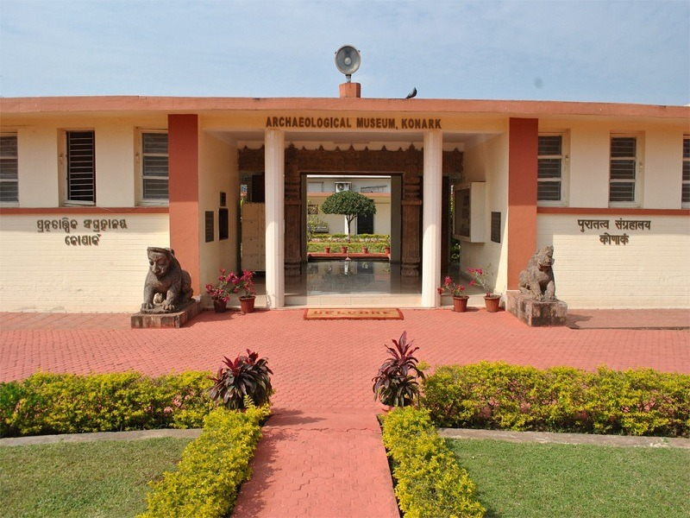
The archaeological site museum is situated at a distance of 1.5 km from Konark. The Konark Museum was started in the year 1968 with the purpose of housing the archeological excavations and the fallen sculptures from the Sun Temple. The museum has four galleries displaying 260 various antiquities. The antiquities include various Sculptures, Paintings, Manuscripts and various fallen parts from the Konark Sun Temple. It is a treasure house for historians and art lovers.
Konark/Chandrabhaga Beach
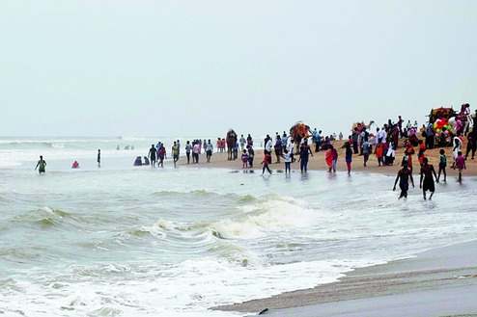
The Konark Sea Beach is named after Chandrabhaga River which joins sea here. The lengthy stretch of sylvan sands and soothing blue sea rushing in, undulating waves makes the Konark Beach one of the beautiful places to visit in Konark. A leisurely stroll along the beachside is a lovely experience. Tourists can also enjoy beach activities like Sun Bathing, Surfing and many more.
Ramchandi
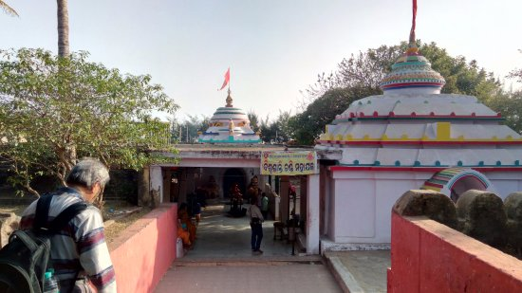
Ramachandi Temple is an ancient temple situated on the banks of Kushabhadra River near Konark in Odisha state. Situated on the Marine Drive Road from Konark to Puri, it is one of the popular places of pilgrimage in Odisha.
Apart from the temple, Ramachandi Beach situated at the merging point of Kushabhadra River and Bay of Bengal is another attraction here. The beach is named after Goddess Ramachandi. Covered with golden sands and huge palm trees, the beach is ideal for taking long walks and collecting shells. The beach offers some activities like Sailing, Boating, Swimming and Sun Bathing.
Kuruma Buddhist Site
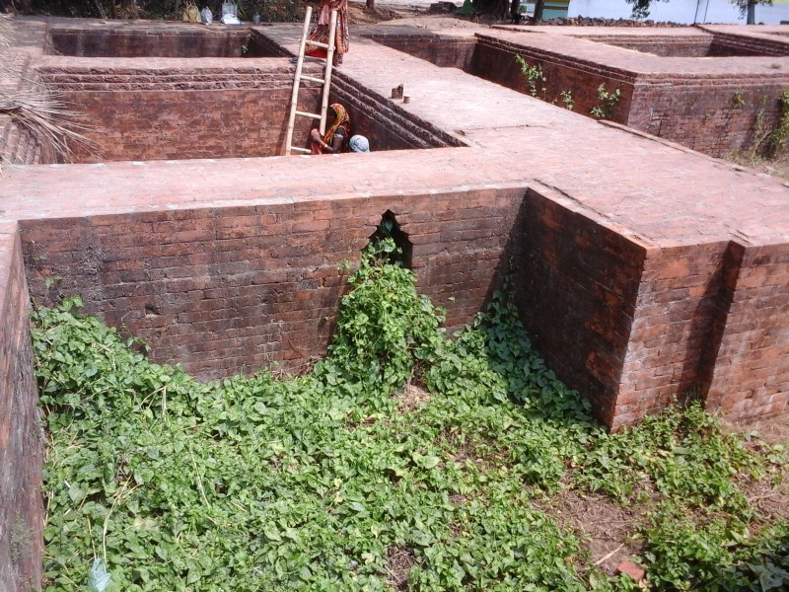
Kuruma is one of the major archaeological excavation sites in Odisha and is mentioned in several Buddhist texts from Ashoka and Ceylon and also appears in the writings of the Chinese traveler Hieun Tsang. The origin of the site is dated to be between 8th-9th century AD and is a must visit for everyone who likes to explore the history of India.
Ashtanga Beach
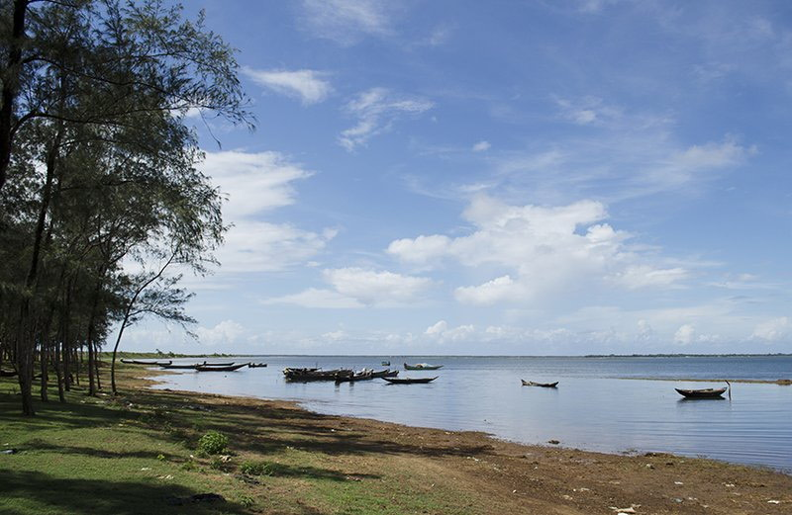
Ashtanga is a stunning beach, situated near the mouth of Devi River, it is one of the famous and beautiful tourist places in Konark.
It lies on the coast of the Bay of Bengal and is famous for the lovely and long sandy beach. It attracts lots of visitors to enjoy the natural scenery of the beach. The sunset at Astaranga Beach is incredible for tourists. In the Odia language “Asta” means “Sunset” and “Ranga” means Color, So “Astaranga” means Colorful Sunset.
How to reach Konark
By Air
Bhubaneswar Airport or Biju Pattnaik International Airport is 65 km and around an hour long drive TO the Konark Sun Temple. You can easily get taxis on hire to reach Konark from the Airport.
By Rail
Puri Railway Station is the nearest Railway Station to the Konark Temple. It is 30 km from Konark. You can book Bhubaneswar to Puri trains and then take a taxi to reach the temple.
By Road
Konark Bus Stand is 6 minutes from the Sun Temple. You can board a bus from Puri and reach Konark in an hour. OSRTC and private operators provide bus service from Puri to Konark.

